**Designing and Manufacturing a Soft Waist for Silkworm Robot**

**Abstract**

One of the most important reasons for using robots is to apply them in places where people could not enter or their involvement is dangerous, like inspecting refineries’ pipes or boilers. Today, soft robots have gained special importance due to their high degree of freedom and range of motion. The present study aims to design and manufacture an active soft waist for the silkworm robot to increase its motion capabilities (degree of freedom) using two helical springs in the center of the module and four strings in parallel to springs. Therefore, PID control is used in two open- and closed-loop control modes for module design and fabrication. The results indicate there is about 5 degree difference between the input value given to the system (20 degree) and the output taken from the module (25 degree) in the open-loop control. However, the controller could return the system to the original state with the minimum error (about 1 degree) at both 20 and 45 degree in the closed-loop system.

**Keywords**: Silkworm robot; Soft waist; PID controller; Designing and manufacturing

**1. Introduction**

Today, due to increasing changes and advances in science and technology, robots have replaced humans in many tasks, so that different types of robots with different tasks and structures could be observed. Robots could be classified into different categories, one of which is soft (elastic) robots, a new introduction to robotics. These robots are generally inspired by the environment. Most applications are biological structures inspired by snakes and worms.

Nature-inspired robots are among robot categories. As their name suggests, these robots are inspired by the existing creatures in nature, including animals. For manufacturing these robots, attempts were made to simulate their movement similar to animals’ movement [1]. The nature-inspired robots include swimming, flying and elastic or soft robots.

Soft robotics has recently become one of the important and rapidly growing topics in robotic community, so that its emergence in academia shows the probable occurrence of revolution in the robotics industry [5]. Reviewing the literature revealed the term “soft robot” was first used for a pneumatic hand with mechanical joints. Afterwards, soft robot was gradually used in papers, inventions and other scientific documents. The wide range of robots represents robots or machines are composed of rigid materials. In 2008, the term “soft robotics” was adopted to describe research on robots with compliant joints as well as soft material-based robots with high flexibility and deformability. Shimachi and Matumoto (1990) began their work on soft fingers. Suzumori et al. (1991) published their flexible microactuator made of silicone rubber [6].

The scientists working in Festo Automation Development Company have designed a robotic arm with flexibility and beauty of an elephant’s trunk, which could be very suitable and powerful for transporting various equipment. The bionic research center is inspired by nature to build new models and expand industrial automation systems. The novel design, called assistant transporter inspired by the elephant’s trunk, consisted of a manual axis with multiple ball joints. This robot could pick up and move objects in various directions using the clamp embedded in the trunk tip. As a result, this robot could be a very good assistant for workers in production lines in agriculture and industry [9].

Researchers at EPFL have designed and fabricated a soft reconfigurable surface (SRS) with controllability and multi-mode operation using vacuum power and soft-material actuators. SRS is comprised of a square grid array of vacuum-powered soft pneumatic actuators, in which modules are embedded that enable adjustment, consolidation and control of many degree of freedom. SRS concept is scalable and space efficient and has diverse functional potential [11].

The novel method for creating soft and adaptive receptors is based on combining electrostatic stimulation with electrical optimization force, which enables us to control deformable or fragile objects. Electroadhesion refers to the electrostatic effect of astriction between two surfaces subjected to the electric field. This is a novel and promising mechanism for robotic applications and material handling with more advantages than existing technologies including higher compatibility and flexibility, gentle transfer, less complexity and very little energy consumption [17].

Snake robots are another example of elastic robots. A snake robot is a robotic mechanism designed to move like a biological snake. This mechanism usually consists of modules connected to each other with the ability to bend in one or more planes. High degree of freedom of snake robots makes them difficult to control, but it provides potential locomotion skills in irregular environments [21].

Most of the snake robots have a rigid structure with fixed and unchangeable joints. This type of joints limits snake robots’ degree of freedom, so that none of them could move along the Z axis.

The present research aims to design and manufacture an active soft waist for the silkworm robot in order to increase its motion capabilities (degree of freedom) using two helical springs in the center of the module and four strings in parallel to springs considering PID control in open- and closed-loop control modes.

**2. Methodology (designing and manufacturing)**

**2.1. Active soft waist module calculations**

Increasing robots’ motion capability and degree of freedom is among the applications of this module. The developed system is an automatic robotic system for changing direction at different angles. The operating method of this system is modeled based on the waist of living creatures such as snakes, worms and humans. The waist in living organisms consists of bones, muscles and ligaments. The spring and cable are used to simulate joints and tendons, respectively. A spring is placed in the center and four cables are located around it in parallel and symmetric position. This module has high flexibility with the bending angle of more than 90 degree as well as ability to compress and stretch. Moreover, this module could tolerate about 800 g. The obvious difference between this module and those made so far is that none of them could move along the Z axis and their motion is limited to X and Y planes. Fig. 1 indicates a schematic of the built module.

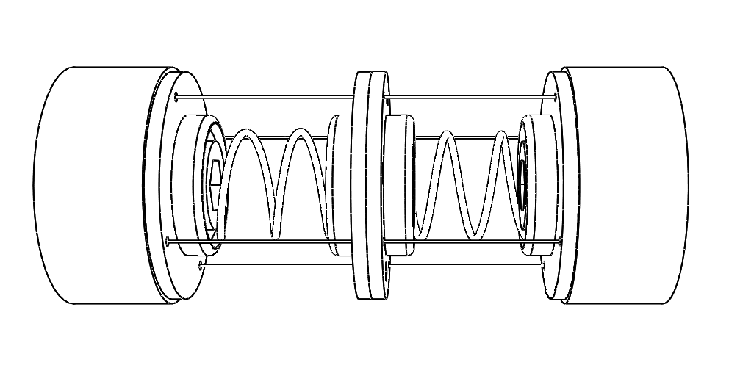

Fig. 1. Schematic of the first design of active soft waist module

In the first fabricated module, a 10 cm spring was used, around which 4 parallel strings made of fishing line were placed because fishing line, despite being thin, has very high resistance.

Using a long spring had a major flaw in design and disrupted movement because when the module moved from the angle of 40 degree upwards, the string hit the spring and prevented the spring from bending further, and increasing the angle caused twisting in the spring.

To solve this problem, the spring was divided into two parts and two short springs were used to construct the module, instead of one long spring. Moreover, a plate was placed between the two springs to prevent the string from hitting the spring when the springs were bent. Calculating the distance between the string placed around the spring and the center of the spring is another effective parameter in module motion and deviation. In the following, an equation is presented based on the spring length and distance between its center and surrounding strings. As indicated in Fig. 2, β is the angle applied to the system and read by the camera which is the control system feedback, α is the angle of the strings to the circle that the spring makes in the bending state and is placed over it, R, shown in red, is the distance between the center of the created circle and center of the spring and L is the spring retaining plate length.

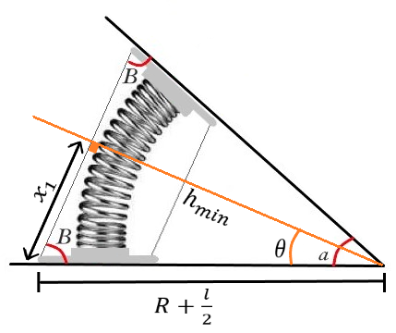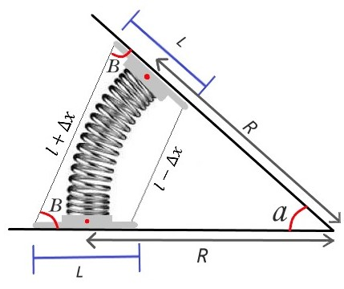

Fig. 2. Spring limit state when the string collides with the spring. The schematic of the spring before string collision and creating an imaginary circle according to the spring arc

According to the proven theorem, when the string hits the spring, the distance between the point where the string hits the spring and the center of the circle made by the spring arc is equal to the radius of the circle, represented by hmin, x1 is the distance between line hmin and spring retaining plate, θ is the angle of radius of the imaginary circle, hmin, and horizon line, and R + L/2 is the distance between the string tip and the center of imaginary circle.

So, we have:

$h_{min}=R$ (1)

In other cases that the string has not yet hit the spring, we have:

$h_{n}>R$ (2)

Since the triangle formed by angles α and β is an isosceles triangle and β angle value is available according to the camera control feedback, α value could be obtained as π-2β.

Now, x1 length should be obtained. Angle θ, which is the angle of triangle x1, R+L/2 and hmin, is first obtained. The angle between x1 and hmin is 90 degree according to the tangent to a circle theorem. Therefore, θ value is equal to:

$θ=\frac{π}{2}-β$ (3)

Since angle θ is available, x1 value could be obtained using sine and cosine equations:

$x_{1}=\left(R+\frac{l}{2}\right)\sin{θ}$ (4)

$x_{1}=\left(R+\frac{l}{2}\right)sin({\frac{π}{2}}-β)$ (5)

$x_{1}=\left(R+\frac{l}{2}\right)sin({\frac{π}{2}})\cos\left(β\right)-\sin\left(β\right)\cos\left(\frac{π}{2}\right)$ (6)

(7)

Now, X1 value should be obtained using Pythagorean equation. Considering that triangle x1, R+L/2 and hmin is a right triangle, if we use Pythagorean equation, R+L/2 to the power of two must be equal to x to the power of two plus h or R to the power of two, then:

$x_{1}=\sqrt{{\left(R+\frac{l}{2}\right)}^{2}-R^{2}}=\sqrt{\frac{l^{2}}{4}+Rl} *$ (8)

Now, according to equations*, x1 value could be obtained in two different ways. Then, they are set equal to obtain β value.

${\left(R+\frac{l}{2}\right)}^{2}\underbrace{\cos^{2}{β}}={\left(R+\frac{l}{2}\right)}^{2}-R^{2}$ (9)

$\cos{β}=\frac{\sqrt{\frac{l^{2}}{4}+Rl}}{\left(R+\frac{l}{2}\right)} →β=\cos^{-1}\left(\frac{\sqrt{\frac{l^{2}}{4}+Rl}}{\left(R+\frac{l}{2}\right)}\right)$ (10)

The state considered here is the final state, in which the spring length is at its minimum state. If the spring has this length, the string hits the spring. Thus, our states must be larger than or equal to it.

$spring length≥Rα$ (11)

where α value is equal to π-2β. The arc length (l1) must be equal to:

$l_{1}<R\underset{α}{\underbrace{\left(π-2β\right)}}<R\left(π-2\cos^{-1}\left(\frac{\sqrt{\frac{l^{2}}{4}+Rl}}{\left(R+\frac{l}{2}\right)}\right)\right)$ (12)

**2.2. Manufacturing an active soft waist module**

Four soft waist modules were designed and manufactured to obtain the desired final module. Fig. 3 shows all the fabricated soft waist modules. Very simple and basic tools were used to construct the first module (Fig. 3a). Four cylindrical pieces were made by a 3D printer to fix the springs and create the initial structure, so that the springs were embedded in the grooves based on the calculated k and the strings were placed parallel to springs in the embedded holes. In this model, servo motors were used, which could tolerate 900 g. Unfortunately, the first built module was large and heavy. The module motors had to be made smaller to reduce the module size, while they had to have enough power to support the robot weight. Therefore, the second soft waist module was designed and built (Fig. 3b). For this purpose, a gearbox motor, i.e., A312 motor, was used. The biggest flaw of this motor was that the gearbox did not include a shaft for the pulley to be connected, to solve which the last gear inside the motor gearbox was replaced with a shaft gear and a hole was made on the gearbox to place the shaft.

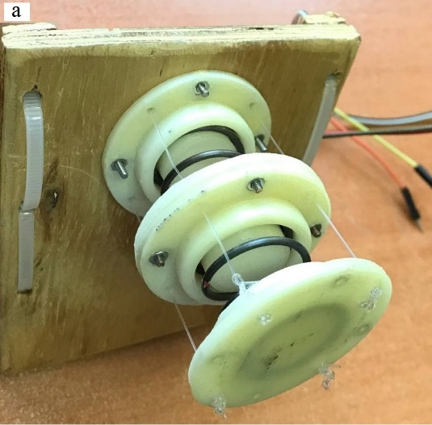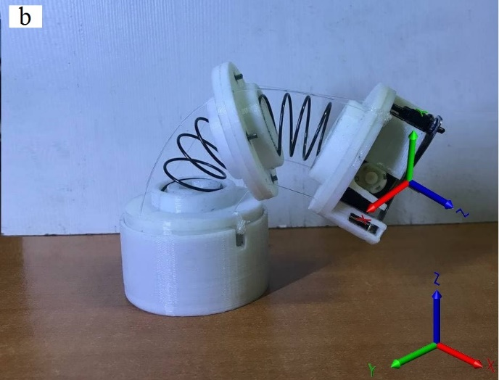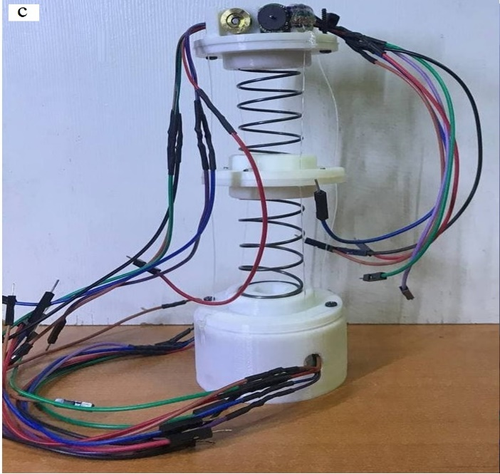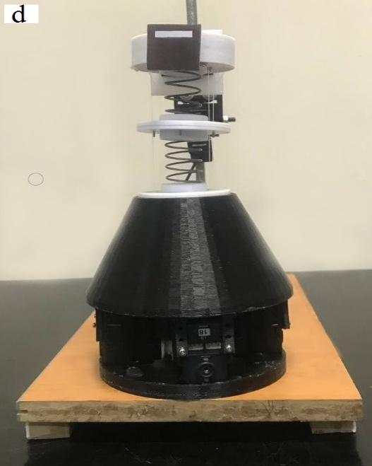

Fig. 3. a) The first sample made of the soft waist model, b) The bending state of the module where the threads have not hit the spring at an angle of more than 90 degree, c) Third generation of the module and d) The fourth generation of active soft waist module

After conducting the second module test, given that the motor gearbox was made of plastic, the tension created in the strings due to the spring contraction during the movement, a bending force was created on the shafts, over which a pulley was placed. This bending force caused the motor gearbox to crack and, eventually, break down. Due to the reasons and problems that the previous generation motors had, modifications had to be made in the module, which led to designing and constructing the third-generation module (Fig. 3c). In this model, an encoder gearbox minimotor was used. These motors are more powerful than the previous generation motors and have a tachometer that could measure the number of revolutions of the motor. Moreover, the technical specification of 12 V motors is 600 rpm.

A 10 mm diameter brass pulley was used to collect the strings in this motor. The tests taken on this module showed its performance was acceptable and the module could move a weight up to 900 g. Finally, the module in the fourth generation was significantly bigger than the previous models because Dynamixel AX12 was used to take more tests (Fig. 3d). Since a camera was employed to detect the module position and control the robot, a large model was built to test the data for ease of handling, so that the only difference was in the motors.

**2.3. Module control platform**

After calibrating the camera to control the module, it was necessary to design and build a platform to fix the module and camera during the control process. For this purpose, a frame was first designed and made by a 3D printer to hold the camera. The main feature of this design was the ability to place the camera at different angles and distances from the module, so that we could have the best field of view compared to Aruco tags.

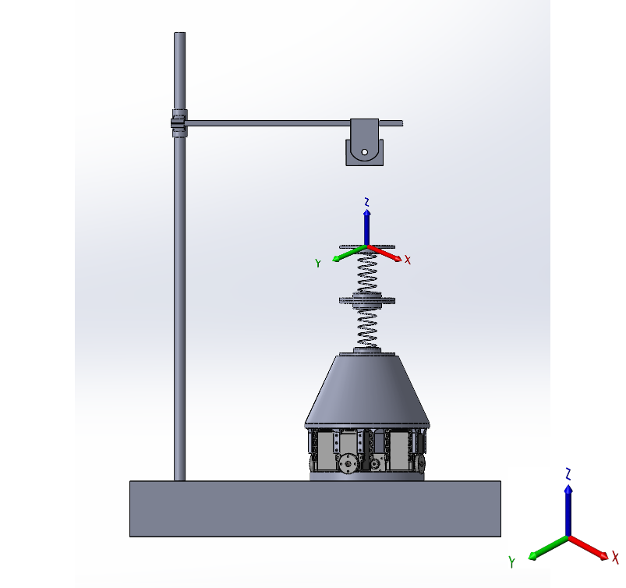

Fig. 4. Robot control platform

Ziegler-Nichols rule was used to obtain PID coefficients, so that Ki and Kd were first set to 0. Kp value was increased until the system started to oscillate around the set point. Then, Kp was decreased to a constant value and Kd was increased until the system reached the set point with a suitable speed and had a slight fluctuation around that point [36, 37]. When the oscillation had a short distance from the set point, Ki value was slowly increased until the steady-state error was obtained. The obtained PID coefficients are as follows:

Kp = 86.05, Kd = 28, Ki = 0.15

There were different methods for calculating the soft waist module angle, two of the most important ones are as follows:

1. Using encoder motor and calculating forward and reverse kinematics of the module for obtaining module position and applying IMU for getting the position feedback

2. Using the camera and augmented reality tag as well as ready-made packages of ROS operating system

**3. Results and discussion**

In this research, two open- and closed-loop controllers were used to control the module angle. In the following, open- and closed-loop control systems are first explained and their output diagrams are then examined.

**3.1. Open-loop control**

Due to the problems in calculating module kinematic equations and given that Dynamixel AX12 could not read 60 degree of the encoder angle in the angle control mode (Fig. 5), the data taken from the camera were completely non-linear. To design an open-loop controller, a series of data had to be collected by system identification method to obtain the conversion function for the system.

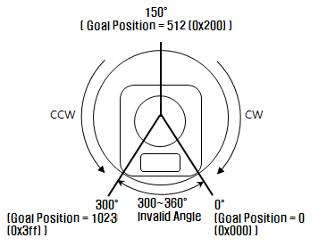

Fig. 5. An image from the angle of view of the dynamic motor encoder

To simplify the problem, the motors and final module actuator were all assumed on the same plane (Fig. 6). Then, the equation of motion of motors was obtained.

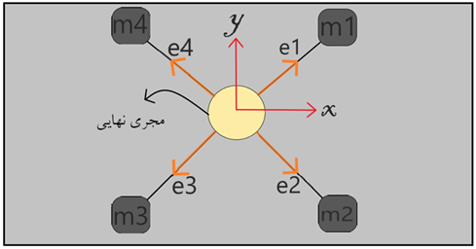

Fig. 6. Engines and finalizer on one page and their overview from above.

where m represents the motors used in the module and e1, e2, e3 and e4 are resultant forces of vectors x and y. Therefore, the equation of motion of motors is as follows:

$X=\frac{\sqrt{2}}{2}\left(e_{1}+e_{2}-e_{3}-e_{4}\right)$ (13)

$Y=\frac{\sqrt{2}}{2}\left(e_{1}+e_{4}-e_{2}-e_{3}\right)$ (14)

Thus, we have:

$x=0.7071\left(e_{1}+e_{2}\right)-0.7071\left(e_{3}+e_{4}\right)$ (15)

$y=0.7071\left(e_{1}+e_{4}\right)-0.7071\left(e_{2}+e_{3}\right)$ (16)

After calculating equations of robot motion, the string length around motor pulley was calculated per second. Considering that Dynamixel motor rate was 27.75 [rev/min] and pulley diameter designed for motors was 12 mm (Fig. 8), we have:

$27.75{rev}/{min}×\frac{1}{60}{min}/s=0.4625{rev}/s$ (17)

$0.4625{rev}/s×\frac{12}{1}{mm}/{rev}=5.55{mm}/s$ (18)

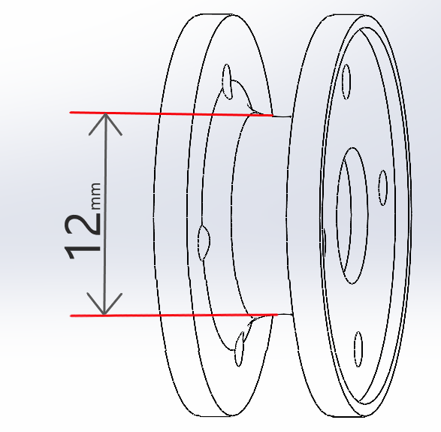

Fig. 7. Money designed for engines

After calculating the motor motion equation and obtaining the string length around motor pulley per second, the module motion was measured in the range of 0.1 s to 1.5 s. The collected data were placed in MATLAB software. Then, a curve was plotted by the curve fitting tool and a conversion function was obtained. Since the camera was located in front of the module, the obtained curve was half of the parabolic segment (Fig. 8). Based on the collected data, the third-order parabola fit the data properly and coefficients (P1, P2, P3 and P4) of the third-order equation were easily obtained. The obtained coefficients are as follows:

$P_{1}=-{2.823}_{e}-06$ (19)

$P_{2}={5.529}_{e}-06$ (20)

$P_{3}=-0.03632$ (21)

$P_{4}=0.1556$ (22)

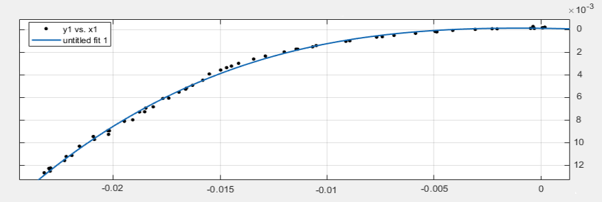

Fig. 8. Collected data and third-degree parametric fit with it

After calculating conversion function coefficients in terms of coefficients P1, P2, P3 and P4, it was found that the input and output of this conversion function were the module’s bending angle and module’s movement duration in seconds to reach the desired angle. Fig. 9 illustrates the results obtained from the conversion function for the angle of 20 degree.

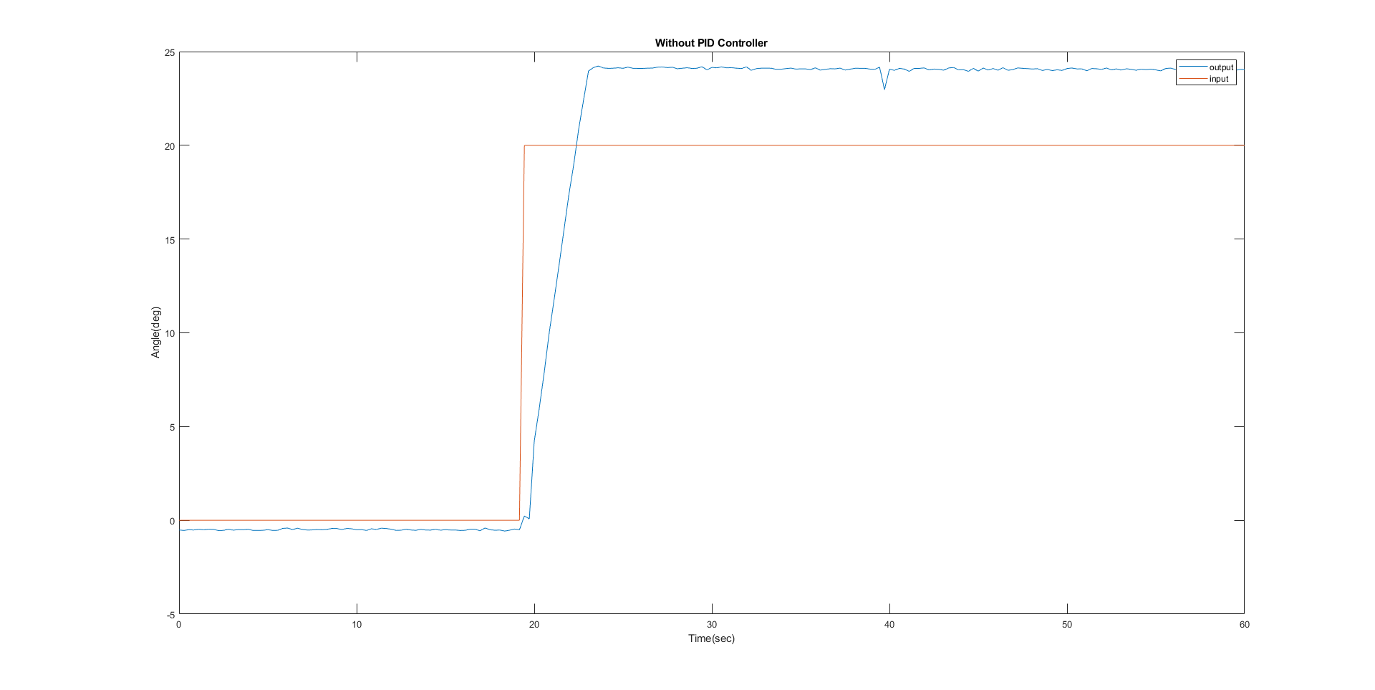

Fig. 9. The orange graph is the input of the step at an angle of 20 degree, and the blue graph is the output of the module at an angle of 20 degree.

As indicated in Fig. 9, there was about 5 degree difference between the input given to the system (angle of 20 degree (red diagram)) and output taken from the module (angle of 25 degree (blue diagram) in the open-loop control system. PID closed-loop control system was employed to resolve this difference.

**3.2. Closed-loop control**

The closed-loop control system, known as feedback control system, uses the concept of open-loop system for the forward path. However, there is one or more loops or feedback paths between its output and input. Closed-loop systems aim to reach the desired output automatically and remain in that condition through comparison with the actual output. The most important features of the closed-loop control are as follows:

1. Reducing errors by automatically adjusting the controlled system input

2. Improving stability of unstable system

3. Increasing or decreasing system sensitivity

4. Increasing resistance to external perturbations

5. Reliable and repeatable performance

Fig. 10 indicates the results obtained from the conversion function at the angle of 20 degree along with PID controller.

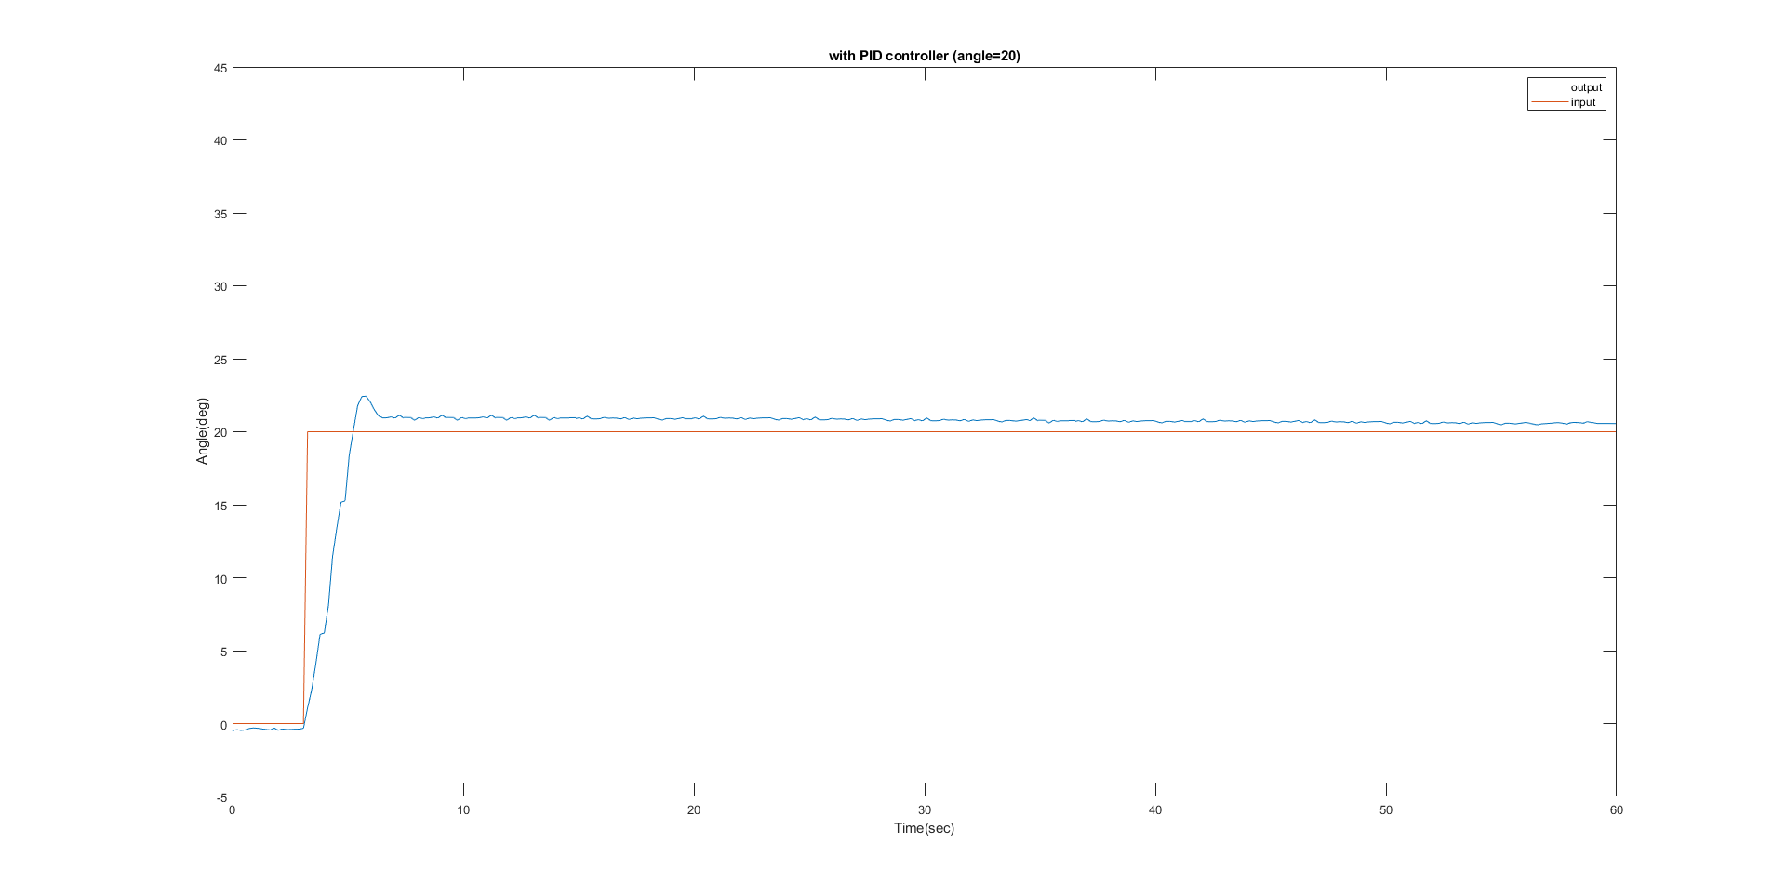

Fig. 10. The orange graph is the input of the step at an angle of 20 degree, and the blue graph is the output of the module at an angle of 20 degree.

As indicated in Fig. 10, there was more than 1 degree difference between the input given to the system (angle of 20 degree (red diagram)) and output taken from the module (angle of 21 degree (blue diagram). To ensure the accuracy of PID controller performance, some tests were performed on the module in the presence of perturbations. For this purpose, a position was defined for the robot. When the module reached the set point, a force was applied to the module end effector to test the controller in the presence of perturbations. This process was done at angles of 20 and 45 degree. Figs. 11, 12 and 13 indicate the obtained results.

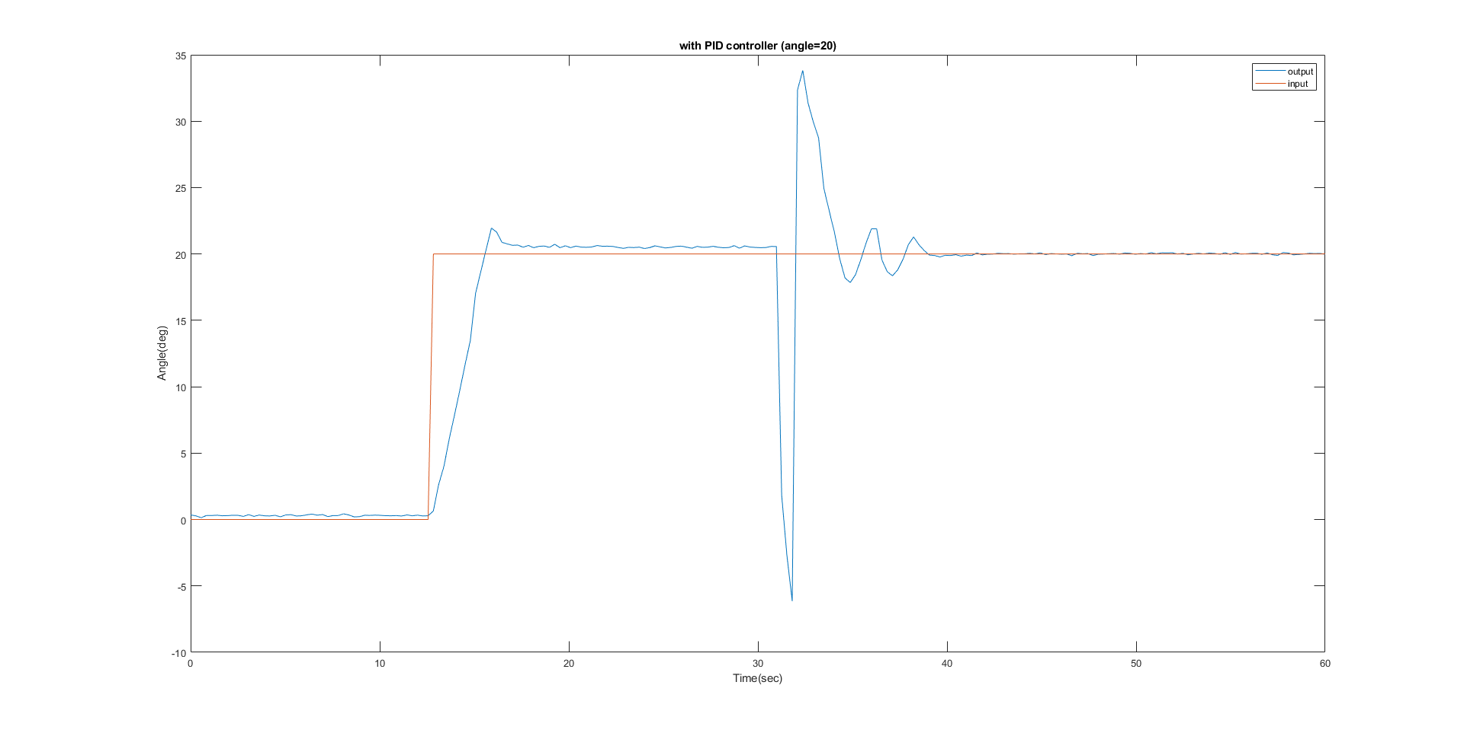Fig. 11. Diagram obtained from P ID control in the presence of disturbance at an angle of 20 degree

As indicated in Fig. 11, despite large perturbations applied to the system, PID controller implemented for the system could quickly return the system to its original state. The same test was performed at angles of 20 and 45 degree, with this difference that the perturbation was applied to the system several times, instead of once. Figs. 12 and 13 indicate the results at angles of 20 and 45 degree, respectively.

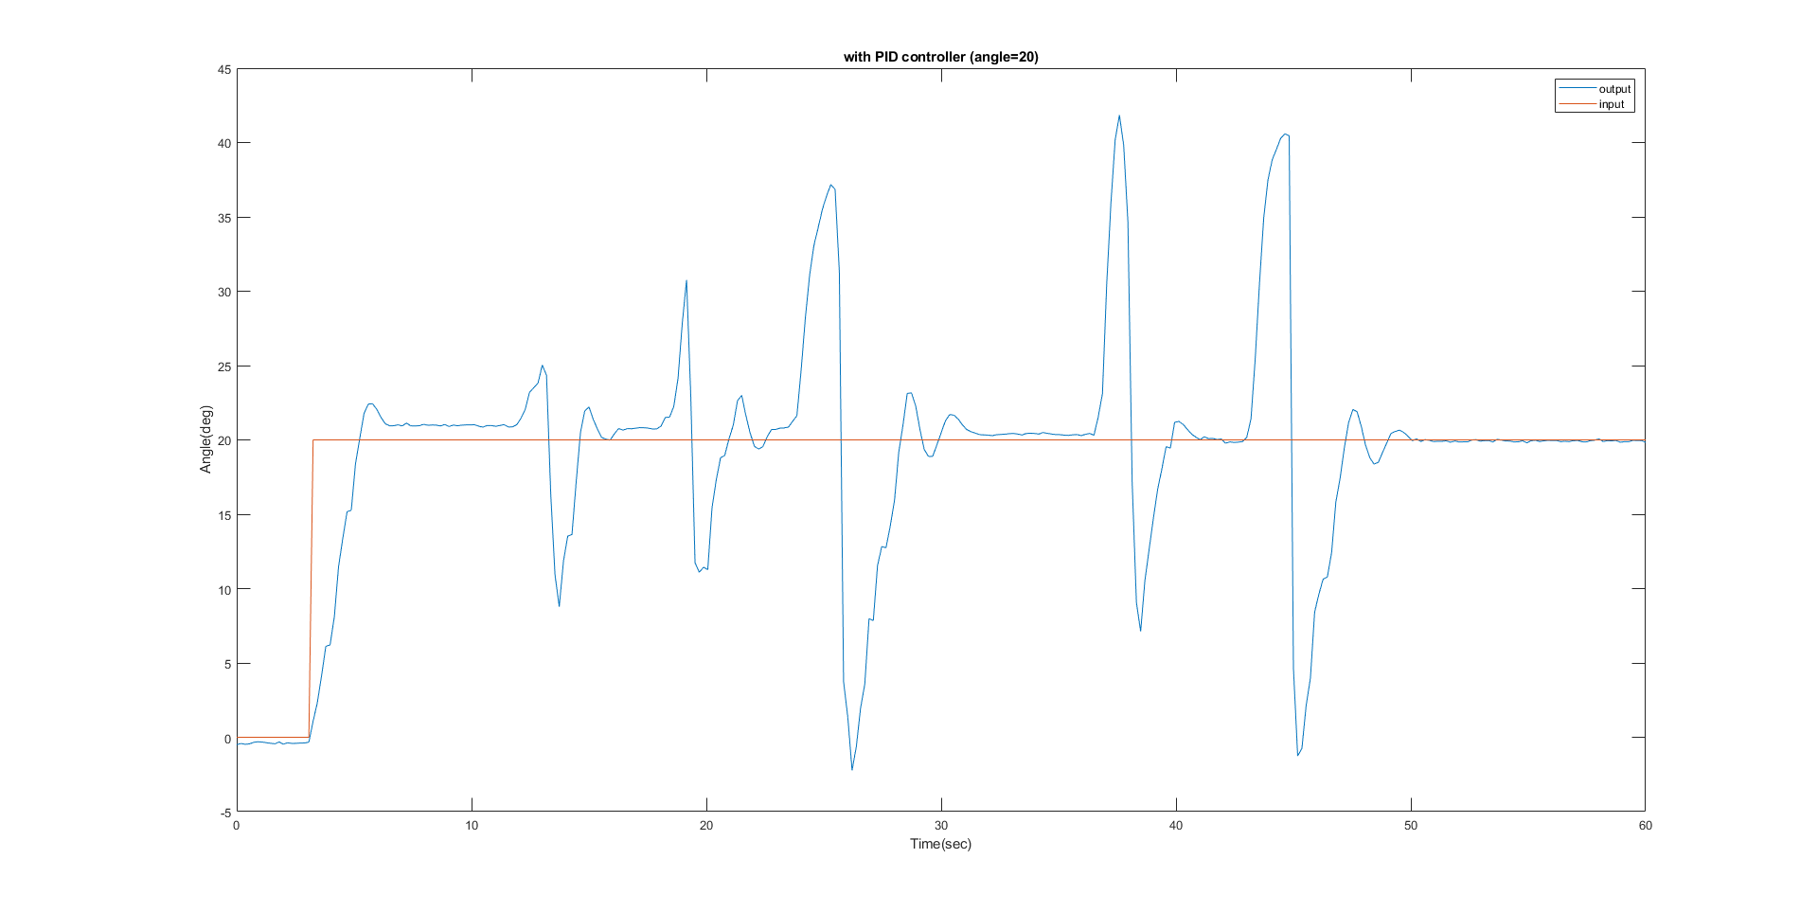

Fig. 12. Diagram obtained from P ID control in the presence of several disturbances at an angle of 20 degree

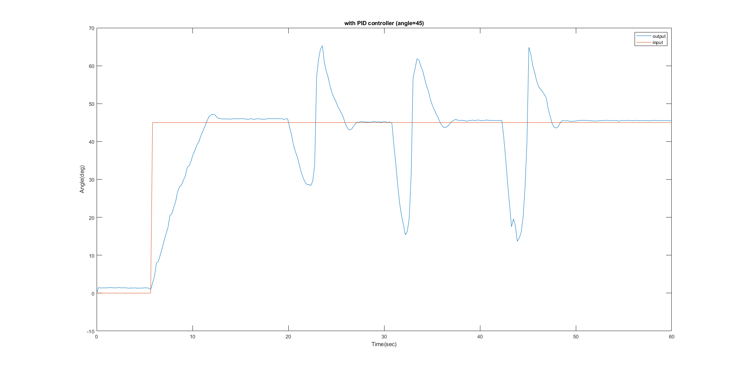

Fig. 13. Diagram obtained from PID control in the presence of several disturbances at an angle of 45 degree.

As indicated in Figs. 12 and 13, the controller could quickly return the system to its original state each time the perturbation was applied (blue diagrams).

**4. Conclusion**

This study designed and manufactured an active soft waist for the silkworm robot to increase its movement capabilities (degree of freedom) using two helical springs in the center of the module and four strings in parallel to springs. Therefore, PID control was employed in open- and closed-loop control modes for module design and construction. This module had high flexibility with the maximum bending angle of 90 degree as well as ability to be compressed and stretched. Moreover, this module could tolerate the maximum weight of 800 g. The results showed there was a significant error between the input given to the system and output taken from the module in the open-loop control. However, the controller could return the system to its original state with the minimum error in the closed-loop system after applying perturbation to the system.